GEO347D final project: Climate change impact on El Nino

Jilong (Mark) Lin jl64985

04/24/2019

**Introduction:**

El Niño, or the warm phase of the El Niño–Southern Oscillation (ENSO) has caught great attention since the late nineteenth century because of its capability to bring extreme events to almost every part of the world. Figure 1 shows the sea surface temperature and wind anomalies in the Pacific during an El Niño event. Michael et al. (2009) points out that El Niño and La Niña (cold ENSO) can affect the frequency, intensity, and spatial distribution of tropical storms, lead to coral bleaching and are able to alter patterns of rainfall, surface temperature and sunlight availability. El Niño events are characterized by anomalous warming temperature and low pressure in the Eastern Pacific. During an El Niño event, the direction of water flow in the Pacific Ocean is totally opposite to that in a normal year: water flows from the Western Pacific to the Eastern Pacific partially due to weakening trade winds. According to figure 2 and 3, El Niño brings a great amount of variations and uncertainties to climatic conditions. Because El Niño events are the most dominant feature of cyclic climate variability on subdecadal timescales, understanding how climate change is altering or will alter the pattern of El Niño gets both scientific and socioeconomic interest (Yeh et al., 2009). The influence of increasing greenhouse gases on ENSO is a critical question in determining the impacts of climate change at the regional scale (Van Oldenborgh et al., 2005).

**Figure 1.** El Niño anomalies in Sea Surface Temperature (SST) (color shading and scale in °C), surface atmospheric pressure (contours), and surface wind stress (vectors) in the Pacific basin. Pressure contour interval is 0.5 mb, with solid contours positive and dashed contours negative. Wind stress vectors indicate direction and intensity (Michael et al., 2009)



**Figure 2.** Global mean temperature anomaly and uncertainty. Global mean temperature is more anomalous and uncertain since the 21st century. The most abnormal temperature observed in 2016 is due to one of the strongest El Niño events in record.



**Figure 3.** Role of ENSO in determining global temperatures. Global sea surface temperatures are closely related with and affected by ENSO.

**Results and discussion:**

While it is important to predict how climate change/global warming is affecting and will affect El Niño, the complexity of the El Niño feedback processes, the wide range of responses of different atmosphere–ocean global circulation models (AOGCMs) and difficulties with model simulation of present day ENSO, all complicate the picture (Matthew, 2004). Matthew (2004) analyzed 20 AOGCMs and found that even though there was a small probability (p=0.16) for a change to El Niño-like conditions, no obvious trend was found on whether future climate change would favor El Niño (warm ENSO) or La Niña (cold ENSO) events.

Van Oldenborgh et al. (2005) analyzed 19 climatic models and found that all these models varied in predicting the mean state of ENSO in 2051–2100. They believed that the reasons for these diverse results are attribute to incomplete understanding of the zonal wind response to equatorial Sea Surface Temperature (SST) anomalies and the SST response to wind and thermocline depth anomalies. Even in their scrutinized analysis, they did not consider the characteristics of the external noise, nor the relationship between zonal wind stress anomalies and thermocline perturbations. With the current data that cover only a short period of time, it is extremely difficult to accurately predict how global warming will alter characteristics of El Niño.

While some researchers did not find impacts of climate change on El Niño, others found some trends of changing El Niño pattern. Yeh et al. (2009) came up with a conclusion that the occurrence ratio of CP- El Niño (El Niño Modoki) /EP- El Niño (the canonical El Niño) is projected to increase under global warming. Figure 4 shows the difference between the CP- El Niño and EP- El Niño. In an EP- El Niño event, SST is maximum in the eastern equatorial Pacific; on the other hand, the center of maximum SST in the CP- El Niño is located in the central equatorial Pacific. In figure 5, eight of the eleven models show an increase in occurrence ratio of CP- El Niño/ EP- El Niño from the 20C3M run to the SRESA1B run and the ensemble mean result shows that there is a significant increase in the occurrence ratio of CP- El Niño/ EP- El Niño. Yeh et al. (2009) suggests that such frequent CP- El Niño events under global warming will lead to more droughts in India and Australia. Lorenzo et al. (2010) studied North Pacific Gyre Oscillation (NPGO) and found out that the low-frequency character of NGPO and increasing variability of NGPO in the late twentieth century are consistent with the finding of increasing occurrence of CP- El Niño. They suggest that the “increase in NPGO power could amplify decadal-scale environmental fluctuations into strong state transitions and therefore may exhibit a high sensitivity to ongoing climate change” (Lorenzo et al., 2010).

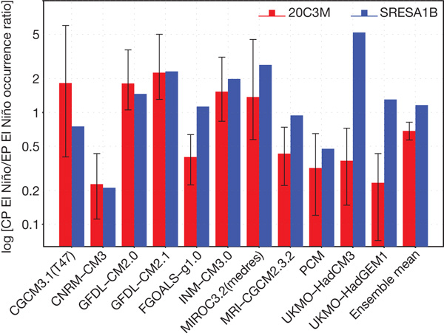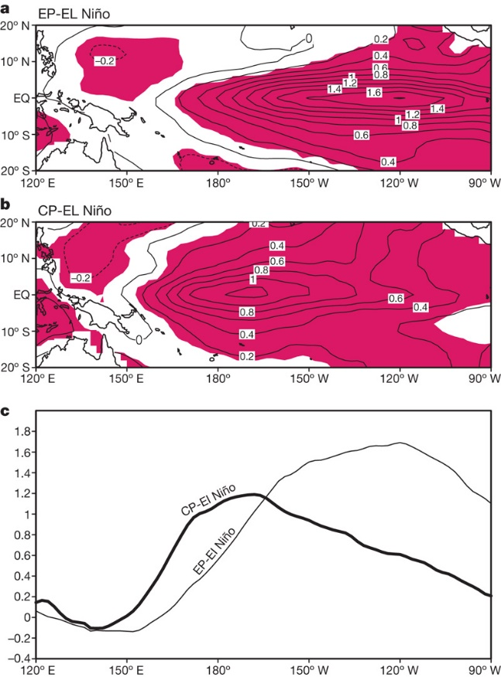

**Figure 4.** a, The EP- El Niño; b, the CP- El Niño. The contour interval is 0.2 and shading denotes a statistical confidence at 95% confidence level based on a Student’s t-test. c, The zonal structure for the composite EP- El Niño (thin line) and CP- El Niño (thick line) averaged over 2N to 2S (Yeh et al., 2009).

**Figure 5.** The CP- El Niño/ EP- El Niño occurrence ratio. ‘20C3M run’ refers to data from the 100-years simulation period for the 20C3Mrun. The term ‘SRESA1B run’ refers to the last 100 years of the SRESA1B run, in which the concentration of CO2 is fixed to about 700 p.p.m. **NOTE:** If the blue bar is above(below) the upper(lower) limit of the vertical error bars of the red bar, there is a significant increase(decrease) of the ratio of the CP- El Niño to the EP- El Niño.

Even though current data is not enough to determine if El Niño will be amplified by global warming, to study how global warming will influence each aspect of El Niño and individual feedback processes in the Pacific may give researchers better understanding. Mat et al. (2010) examined El Niño events with complex coupled global circulation models (CGCMs) and analyzed the impact of global warming on many feedback processes. The researchers suggest that climate change in the Pacific may have a similar pattern as an El Niño event. As greenhouse gas concentration and global temperature continues increasing, vertical circulations of the longitudinal Hadley circulation in the Pacific and the zonally aligned Pacific Walker circulation tend to slow down. This will weaken the surface trade winds and therefore flatten the thermocline (Mat et al., 2010). The decrease in the mean sea-level pressure gradient between the eastern and western Pacific also supports the weakening of the trade wind. The weaker Walker circulation will reduce heat flux in the equatorial region. Without enough heat transporting away from the equatorial Pacific, the temperature will increase and thus further weakening the trade wind. This positive feedback tends to enhance El Niño. However, since it is not always accompanied by decreasing Southern Oscillation Index or a reduction in the magnitude of the east-west gradient of SST, the conclusion that climate change will lead to El Niño-like events is of limited use.

**Conclusion:**

Researches in the 20th century such as Gerald and Warren (1996) and Timmerman et al. (1999) all suggest that climate change will lead to an El Niño-like change or increase El Niño frequency. However, papers in the 21st century are more cautious about phrasing the potential change that El Niño will bring. One likely reason is that there were not enough models in the 20th century, so most researches analyzed one single model and made a conclusion. After researchers understand El Niño better and multiple models were built to analyze climate change in the Pacific, it became difficult to come up with a conclusion that satisfies most of the models. Moreover, the climate variation of El Niño itself is large enough that it becomes very difficult to prove that the variation found in the researches exceeds the natural variation.

Nonetheless, with the efforts of various researchers put in El Niño and climate change, some trends can still be found through extensive researches. It is very likely that global warming will lead to El Niño-like events due to weakening trade winds and flattening thermocline. On the other hand, CP-El Niño is becoming more frequent under global warming and it needs to be further studied.

Reference:

* Collins, Mat, et al. "The impact of global warming on the tropical Pacific Ocean and El Niño." Nature Geoscience 3.6 (2010): 391.
* Collins, Matthew. "El Niño-or La Niña-like climate change?." Climate Dynamics 24.1 (2005): 89-104.
* Di Lorenzo, E., et al. "Central pacific El Nino and decadal climate change in the North Pacific ocean." Nature Geoscience 3.11 (2010): 762.
* McPhaden, Michael J., Stephen E. Zebiak, and Michael H. Glantz. "ENSO as an integrating concept in earth science." science 314.5806 (2006): 1740-1745.
* Meehl, Gerald A., and Warren M. Washington. "El Niño-like climate change in a model with increased atmospheric CO2 concentrations." Nature 382.6586 (1996): 56.
* Timmermann, Axel, et al. "Increased El Niño frequency in a climate model forced by future greenhouse warming." Nature 398.6729 (1999): 694.
* Van Oldenborgh, Geert Jan, S. Y. Philip, and Matthew Collins. "El Niño in a changing climate: a multi-model study." Ocean Science 1.2 (2005): 81-95.
* Yeh, Sang-Wook, et al. "El Niño in a changing climate." Nature 461.7263 (2009): 511.